Jeremia Faust

CS-470 Full Stack Development II

Professor M. Shah Alam

February 5, 2023

**Module Five Assignment Two**

The Query Lambda

Single-Record Fetch

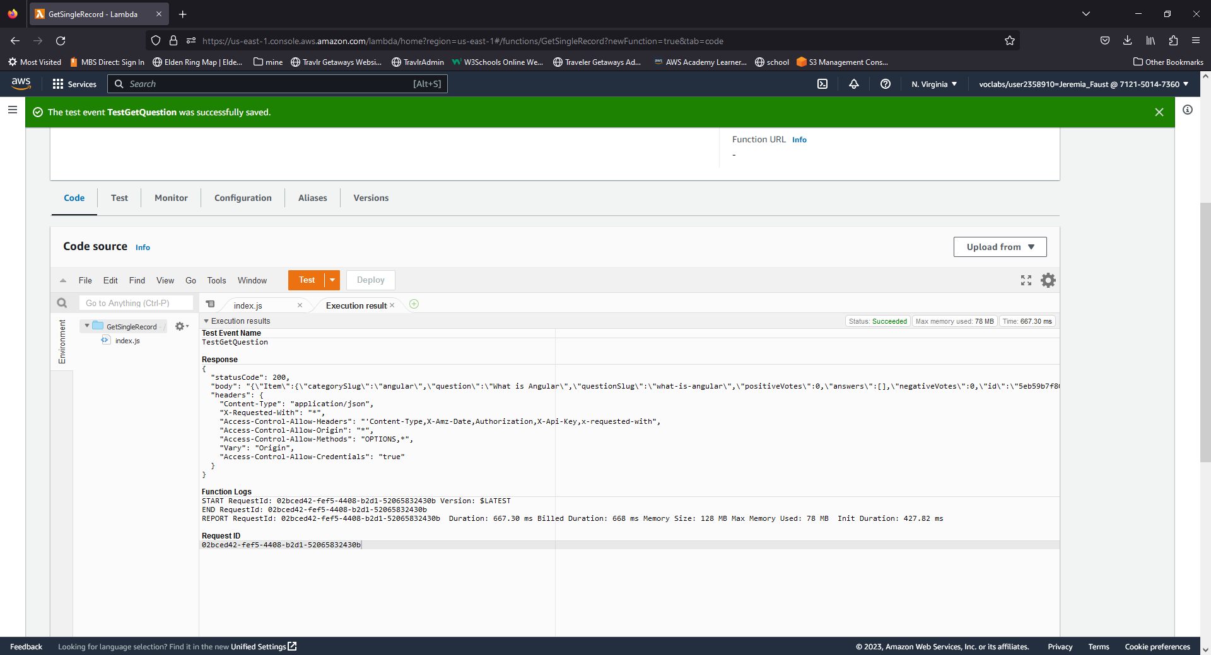

Deleting Records

Before

After

All the functions

Roles

